**GPAC USER MANUAL**

This document is meant as a comprehensive guide to constructing, and utilizing the LC115 circuit board/General Purpose Animation Controller (GPAC).

**Documentation By:** Palmer Insull

**Board Designed By:** Palmer Insull, Phil Insull

**Contact Information:**

* [palmeri@little-canada.ca](mailto:palmeri@little-canada.ca)
* [palmer7987@gmail.com](mailto:palmer7987@gmail.com)



# 

# 

# 

# 

# Table Of Contents

**Table Of Contents** **2**

**Introduction** **2**

**Capabilities** **3**

**Glitches/Issues/Considerations** **3**

Known Issues 3

Issue Log 4

**GPAC Code** **4**

**Github** **5**

**Circuit Diagram** **5**

**Pinout** **5**

**Parts List** **7**

**Construction** **8**

Tools And Equipment 8

Part Installation Order 9

Board Reference Images 9

# Introduction

The LC115, or General Purpose Animation Controller (GPAC). Was designed in order to provide an easy-to-use and ESA compliant control solution to many of the existing animations throughout Little Canada’s destinations. It is designed essentially to be an Arduino peripheral shield, similar to many products offered by vendors such as DF robot or Adafruit while having key features such as fusing/current-limiting and an opto-coupled trigger input. The board was designed so that many of the Little-Canada staff at the time could use it with ease, without advanced knowledge of Arduino Code (C++), and without the need for a specialized control library.

# Capabilities

**Outputs**

The GPAC has the ability to control 3 and optionally 4 (selected via solder pads) Full bridges for Bi-Directional motor control of up to 4 motors, or control of 8 Servos, or control of 2 Stepper motors (Or a compatible combination of those devices).

**Digital Inputs**

The GPAC has 2 designated digital input terminal sets and optionally 2 more (selected via solder pads). Each input set offers a 5V supply, connection to the level-shifted input, and a ground connection.

**Trigger Input**

An opto-coupled input designed to be used as a show control trigger input, as well as a passthrough is also present on the GPAC.

**Power Supply**

The fused 12V or 5V on board can also be used to feed low power devices. (located on each output terminal, DO NOT USE THE 12V PASSTHROUGH UNLESS THE DEVICE IT IS FEEDING IS ADEQUATElY FUSED)

# Glitches/Issues/Considerations

## Known Issues

| **Issue Description** | **Solution Or Workaround** |
| --- | --- |
| Seeduino XIAO Microcontroller won’t show up under “Ports” in the Arduino IDE. | Provided the driver is installed and a working cable is connected, it is possible that Arduino may not appear until external power (From a power supply and USB cable) is first disconnected, before just the USB cable is re-connected. Furthermore, the 2 exposed gold pads on the top of the chip may need to be shorted until the on-board LED stays orange, to reset the bootloader. |
| Can’t Run 8 Servos at once!?  Or can’t run certain servo pins at the same time as certain PWM pins... | A special library has been written for this case in which you want to run all 8 servos, see GPAC_Servo library in this document, and on Github. |
| It Is shorting out the trigger wires |  |

## Issue Log

| **Issue Description** | **Issue Date** | **Solution Or Workaround** |
| --- | --- | --- |
|  |  |  |
|  |  |  |

# GPAC Code

Since the GPAC is designed to be accessible to those with basic knowledge of Arduino, it can be programmed like any other arduino device using a driver board. For the purpose of running many of Little-Canada’s sufficiently simple (animations that by design should follow a simple motion profile), some Code was written in order to set up “Journeys” for different devices to simply run and tune GPACs that run multiple concurrent simple animations. The main reason this code was written was for the rapid deployment of animation controllers with the ability to tune behavior specific to each animation, accommodating the different voltages requirements and ranges.

For example, the GPAC originally situated in Niagara on the Lake drove 3 animations through this scheme, where only the voltages, speeds (ratio), pins, and timings were plugged into an array, and the GPAC automatically generated and ran the motion profile with the corresponding speeds and ramps. Example well-commented code using this scheme is in the Github repo titled: **GPAC_Motion_Profiles**. This code was written by Palmer Insull, reach out via the contact info provided if more explanation is required, or assistance is required in maintaining this code.

# 

# Github

A github repository has been made in order to store documentation and code pertaining to the GPAC

<https://github.com/Palmer-LC/GPAC-Repo>

# Circuit Diagram

Below is the circuit Diagram for the GPAC (The PDF is also on the Github repository).

# 

# Pinout

**Pinout of the chosen Microcontroller, the Seeduino XIAO**

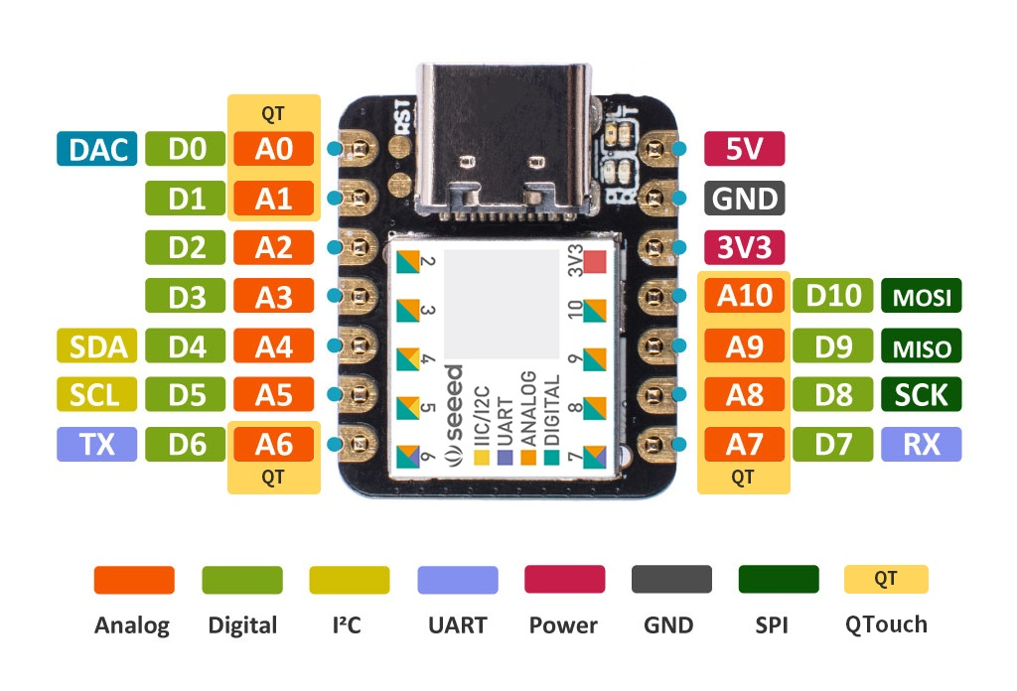

**Gpac Pinout**

| **Pin** | **Function** | **Location On Board** |
| --- | --- | --- |
| 0 | Optocoupler Input Pin | T1, T2 |
| 1 | Input Pin 1 | IN1 |
| 2 | Input Pin 2 | IN2 |
| 3 | Output 1 | OUT1, Controls Channel 1 of Motor Driver A |
| 4 | Output 2 | OUT2, Controls Channel 2 of Motor Driver A |
| 5 | Output 3 | OUT 3(Labeled OUT2), Controls Channel 1 of Motor Driver B |
| 6 | Output 4 | OUT 4(Labeled OUT3), Controls Channel 1 of Motor Driver B |
| 7 | Output 5 OR Input 3 | OUT 5(Labeled OUT4), Controls Channel 1 of Motor Driver C Or Input 3  (Selectable via solder pads on the bottom of the board) |
| 8 | Output 6 OR Input 4 | OUT 6(Labeled OUT5), Controls Channel 1 of Motor Driver C Or Input 4  (Selectable via solder pads on the bottom of the board) |
| 9 | Output 7 | OUT 7(Labeled OUT6), Controls Channel 1 of Motor Driver D |
| 10 | Output 8 | OUT 8(Labeled OUT7), Controls Channel 1 of Motor Driver D |
| 11 (3V3) | Logic Voltage | Not directly accessible, used in PCB for logic-level voltages. |
| 12 (GND) | Ground | All grounds are all connected via the ground plane. |
| 13 (5V) | 5V Input | Not Used On PCB, separate 5V supply is used, XIAO is powered Via the 5V pin. |

**Diagram of GPAC**

# Parts List

**GPAC BOM**

| **Component** | **Qty** | **Reference** | **Manufacturer's Part Number** | **Comments** |
| --- | --- | --- | --- | --- |
| Seeduino XIAO | 1 | - | Seeduino XIAO |  |
| Motor Driver | 4 | - | DRV8871DDA |  |
| Switching Voltage Regulator 5V 2A | 1 | - | mEZD72402A-G |  |
| 6-Position Phoenix Contact Terminal | 6 | - | TERM-BLK-PTSA0,5_2-F |  |
| 2-Position Phoenix Contact Terminal | 4 | - | TERM-BLK-PTSA0,5_6-F |  |
| 2mm 3-Position Jumper Header | 1 | H0 | CONN-HDR-1ROW-2W-2MM |  |
| 2mm 2-Position Jumper Header | 1 | H1 | CONN-HDR-1ROW-3W-2MM | Cut from 2mm 3-Position header. |
| Samtec SMD 7-Position Header (For XIAO) | 2 | J1, J3 | TSM-107-01-L-SV |  |
| Samtec SMD 3-Position Header (For Voltage Regulator) | 1 | J4 | TSM-103-01-S-SV-TR |  |
| 3 Position Servo-Header | 8 | H2, H3, H4, H5, H6, H7, H8, H9 | Don't Need Any More... Ever... | Cut from headers left over from Pico MCU... |
| Fuse 3A 15V POLYFUSE | 1 | F1 | Same As K-Board |  |
| Fuse 0.25A 16V LITTLEFUSE | 1 | F3 | Same As K-Board |  |
| FET For Sensors | 4 | Q1, Q2, Q3, Q4 | BSS138 |  |
| Opto Isolator | 1 | OPTO | LTV-356T |  |
| Zener Diode 5V 250mW | 8 | D5, D6, D7, D8, D9, D10, D11, D12 | PLVA650A |  |
| Schottky Diode 5A | 2 | D3, D4 | Same As K-Board |  |
| Rectifier Diode 50V 1A | 2 | D1, D2 | Same As K-Board |  |
| 0.1uF 805 Capacitor | 4 | C1, C3, C5, C6 | - |  |
| 2.2uF 1206 Capacitor | 1 | C20 | - |  |
| 10uF 1206 Capacitor | 1 | C12 | - |  |
| 47uF Panasonic D Capacitor | 4 | C2, C4, C7, C8 | GYB1J220MCW1GS |  |
| 270/330 Ohm 805 Resistors | 8 | R9,R10, R17, R18, R28,R20, R21, R22 | - |  |
| 470 Ohm 805 Resistors | 1 | R1 | - |  |
| 10K Ohm 805 Resistors | 9 | R4, R5, R11, R12, R13, R14, R15, R16, R8 | - |  |
| 66K Ohm 805 Resistors | 4 | R2, R3, R6, R7 | - |  |

# Construction

Similar to most other LC Circuit boards, the GPAC is designed to be constructed using both through hole and surface mount techniques. At the time, there were many many Little-Canada employees well versed in surface mount soldering, and pcb assembly make use of them if they are available. Training is practically mandatory to ensure that functional and reliable boards are made.

## Tools And Equipment

The recommended tools and equipment required to manufacture a GPAC are the following:

* Soldering Iron
* Solder
* Solder Paste
* Solder Paste Dispenser
* Reflow Oven
* Fine Tipped Tweezers
* Helping Hand
* Templates (Optional, useful for or holding components in the correct spot)
* Desoldering Tool (Very optional, but useful for fixing mistakes)

## Part Installation Order

It is recommended for ease of construction that this order of components is followed for construction. This recommended order is as follows:

1. All surface-mount components, apart from the XIAO headers and the DC-DC converter. Ensure that you put solder paste underneath the DRV8871 motor drivers, for heat dissipation through the vias to the ground plane.
2. The XIAO headers (Using a XIAO with sockets as a template, see figure below), please ensure that you solder all of the pins you can access before very gently removing the template to solder the inner pins (Otherwise the force course damage and lift the traces). The DC-DC converter with the gold ground pound facing upwards and the DC-DC converter should be pointed towards the XIAO, not pointed out of the board.
3. The 2mm optocoupler (3 and 2 pin) headers. The 2mm Shunts can go on at this time as well. (Position shown in Figure below)
4. The 8 servo headers.
5. Finally the green phoenix contacts 6X and 2X push-button terminal blocks.

Pro-Tip: Sometimes bandaids on your fingers, thick fabric ones in particular can be great for holding metal pins to a pcb while soldering the other side. May the reasons those bandages got there be intentional, as frequently as possible.

## Board Reference Images

On the following pages, are references to images for a correctly assembled GPAC board, for comparison. A tested physical reference model should also be kept and available during assembly as well.

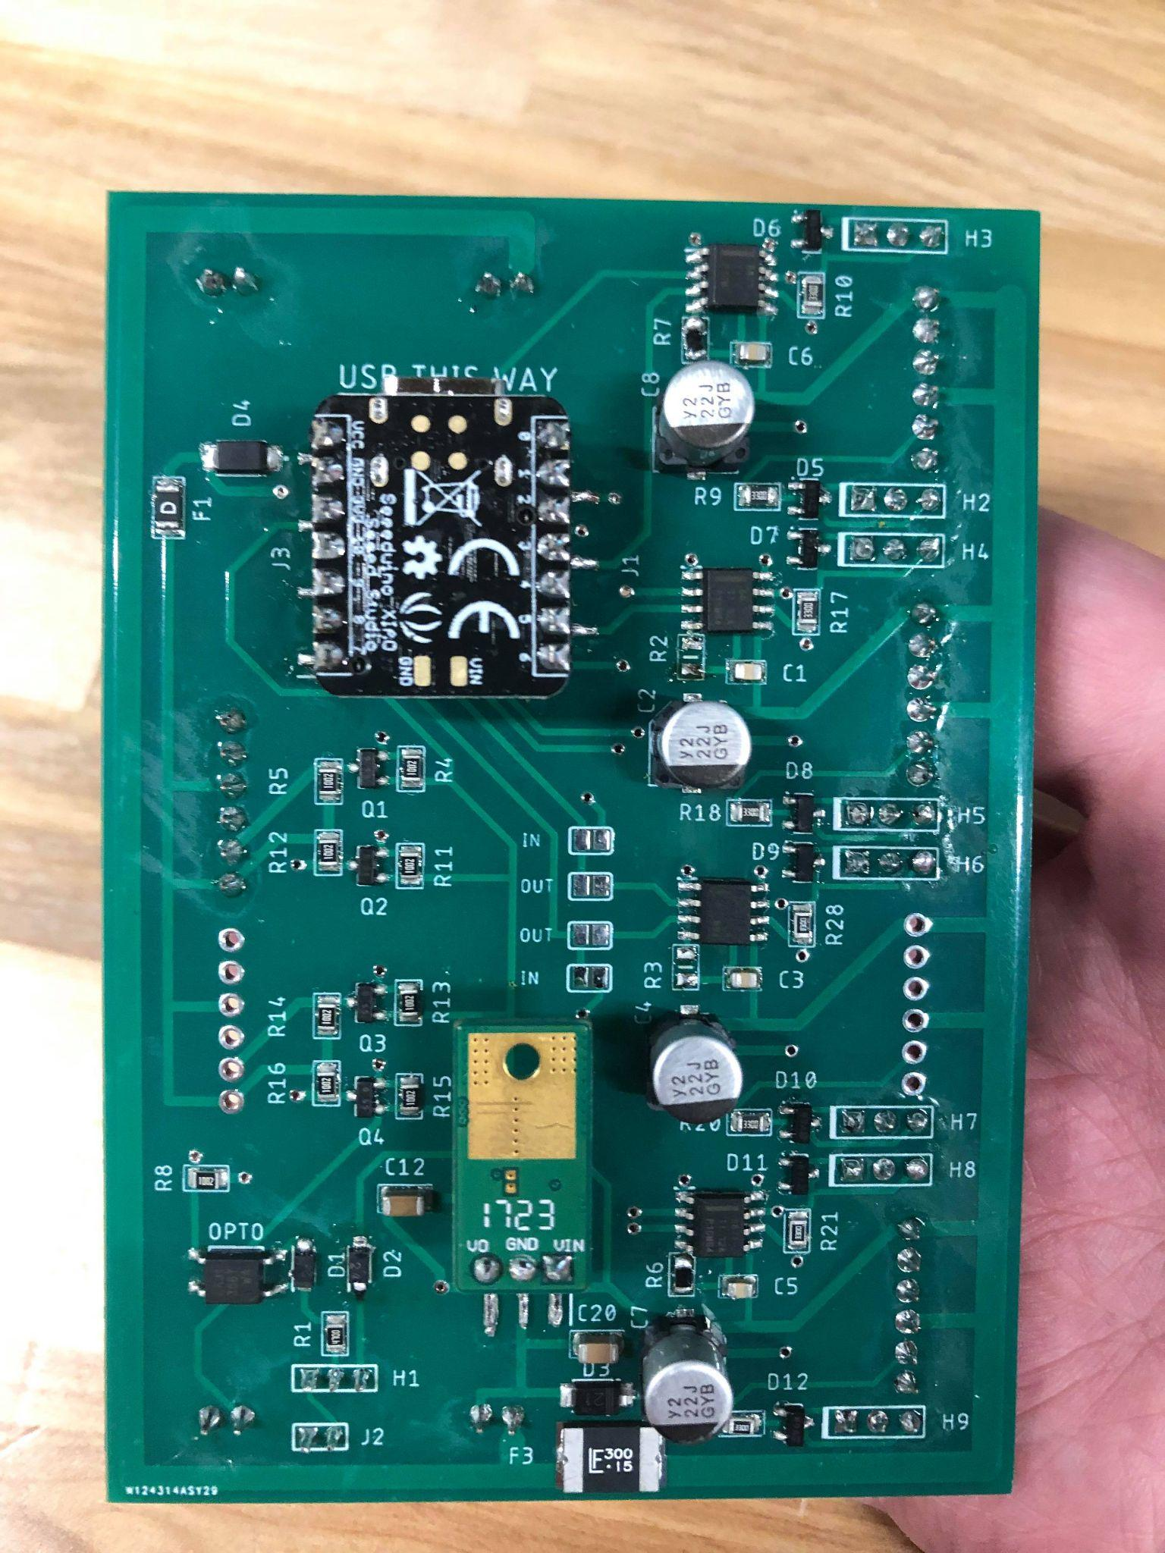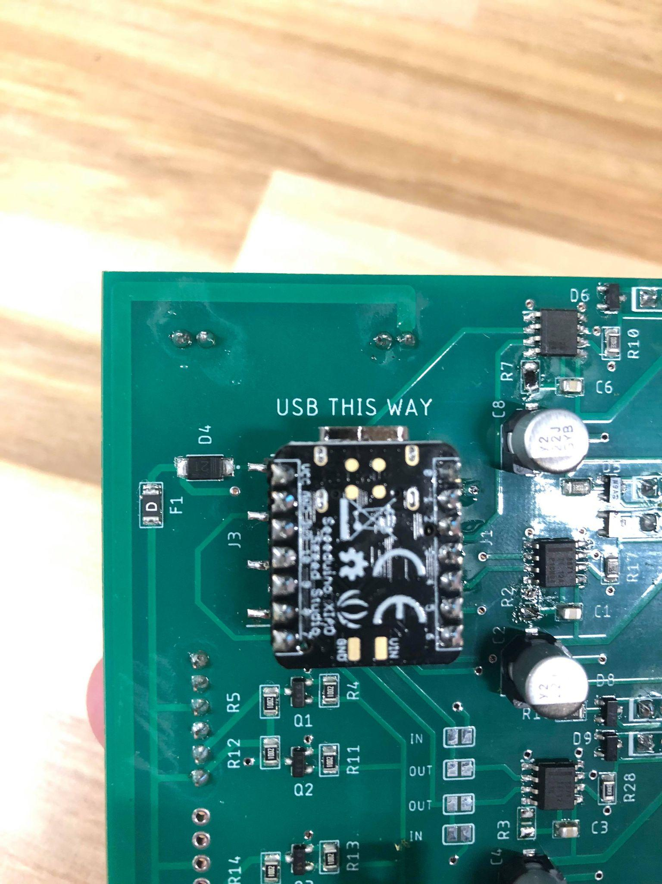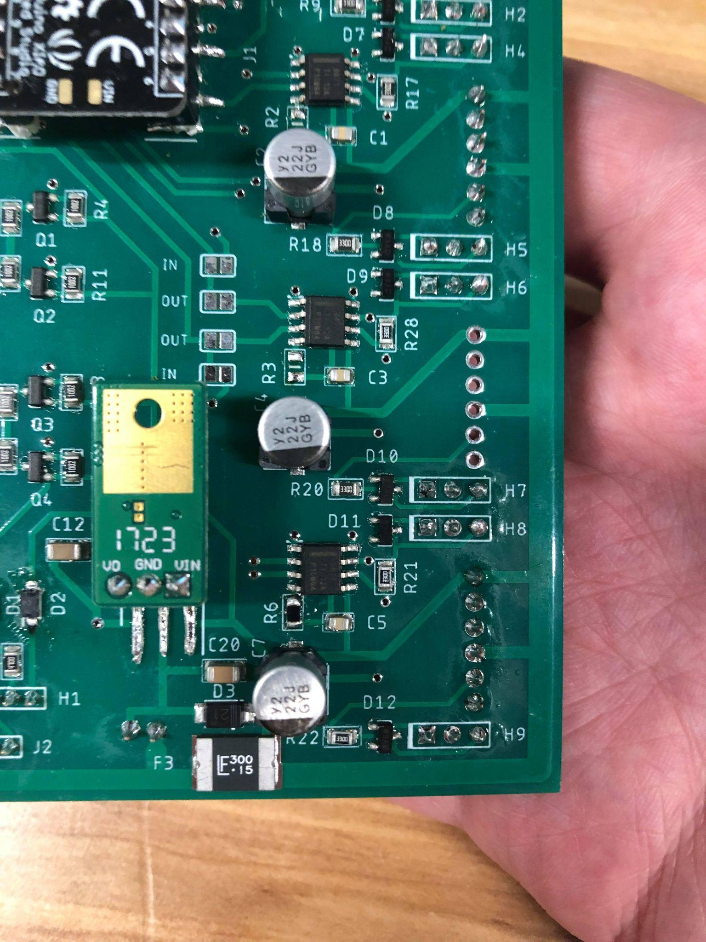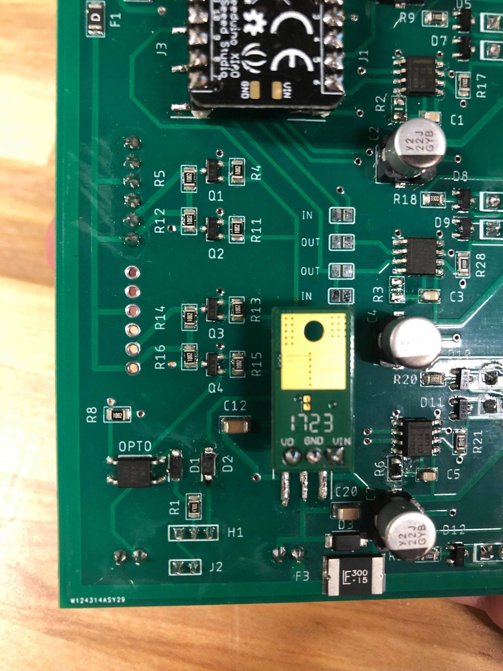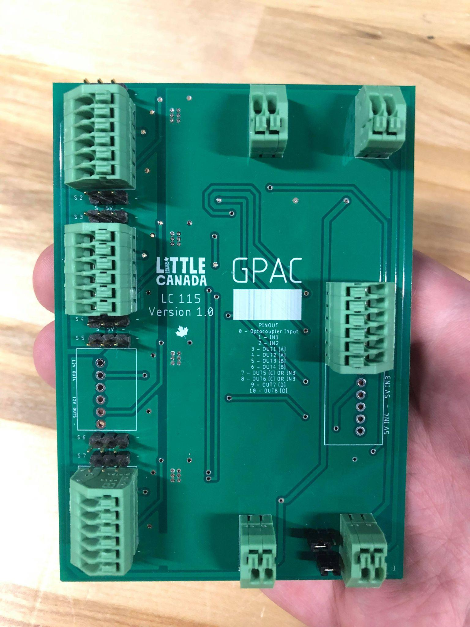

* Note the correct positions for the 2mm shunts for the opto-coupler, for a volt-free contact trigger setup.

# GPAC ANIMATION BRIEF TEMPLATE

Accompanying each installed GPAC, there should be a animation brief which consists of a diagram of the GPAC, How it is wired with each animations, a description of its uses, a pointer to the correct code and version it is using, a log of updates made to the code or wiring, and contact information of those responsible for creating, updating, and repairing the animations associated to a particular GPAC. A template for the GPAC animation brief is